Project Design Phase-II
Technology Stack (Architecture & Stack)
Date | 18 June 2026
Team ID | N/A
Project Name | Book-A-Doctor Healthcare Appointment Management System
Maximum Marks | 4 Marks
Technical Architecture:
The deliverable includes the architectural diagram below and the information as per Table-1 and Table-2. The diagram shows the Book-A-Doctor MERN application workflow, technology blocks, storage components, external interfaces and deployment options.
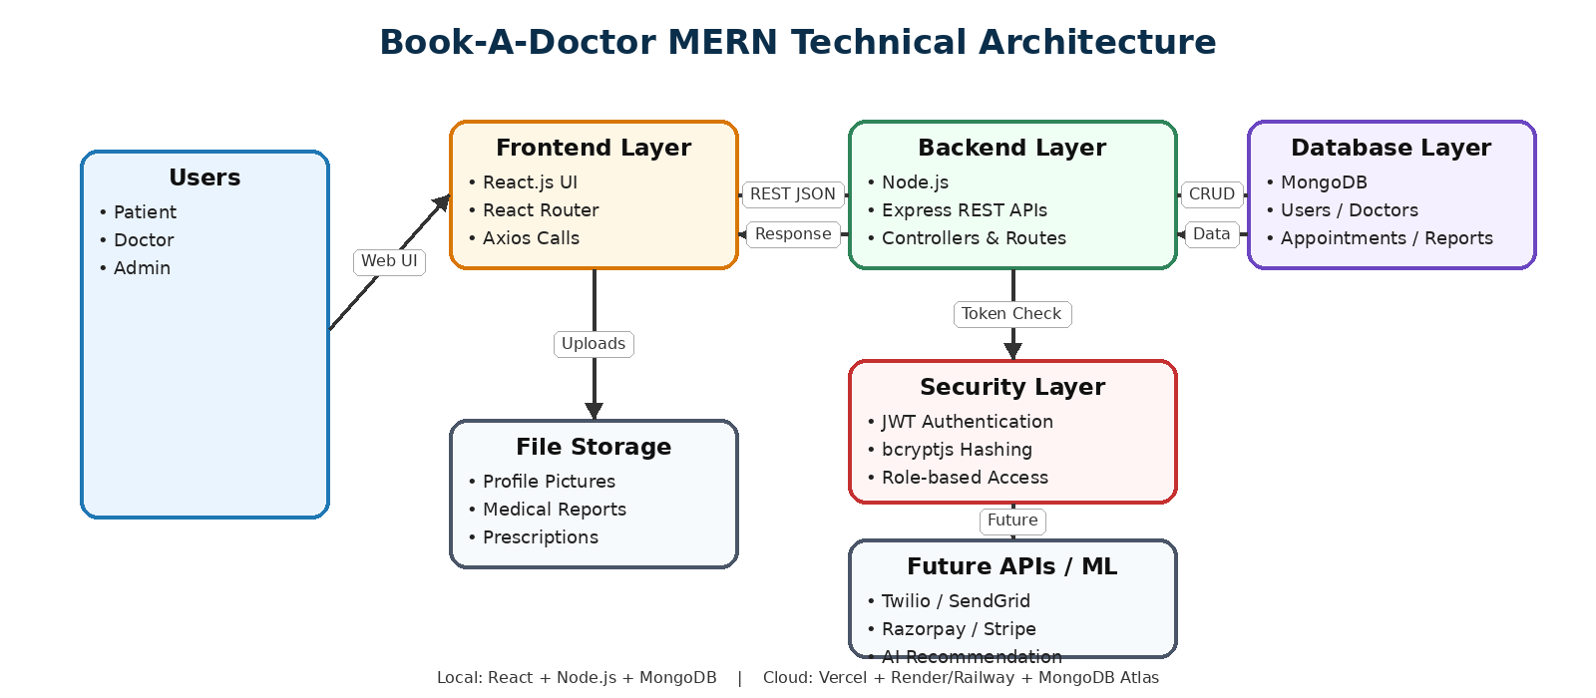
Figure 1: Book-A-Doctor MERN Technical Architecture

Table-1 : Components & Technologies:
S.No | Component | Description | Technology
1. | User Interface | Web interface for Patient, Doctor and Admin dashboards including login, doctor search, appointment booking, profile management and reports. | React.js, HTML5, CSS3, JavaScript, React Router, Axios
2. | Application Logic-1 | Authentication, authorization, user registration, login, profile update and role validation. | Node.js, Express.js, JWT, bcryptjs
3. | Application Logic-2 | Appointment workflow including booking, cancellation, rescheduling and appointment status updates. | Node.js, Express.js, REST APIs
4. | Application Logic-3 | Doctor approval, admin statistics, patient management, doctor management and dashboard reporting. | Node.js, Express.js, MongoDB queries
5. | Database | NoSQL database for storing users, doctors, patients, appointments, prescriptions, reports and notification records. | MongoDB
6. | Cloud Database | Cloud database option for scalable deployment, backup, monitoring and remote database access. | MongoDB Atlas
7. | File Storage | Storage for profile pictures, uploaded medical reports, prescriptions and health documents. | Local File System / Cloud Storage
8. | External API-1 | Future notification service for appointment confirmations, cancellations and reminders. | Twilio API / SendGrid API
9. | External API-2 | Future online payment and transaction processing for consultation fees. | Razorpay API / Stripe API
10. | Machine Learning Model | Future enhancement for AI-based doctor recommendation using symptoms, specialization and patient history. | Recommendation Engine
11. | Infrastructure (Server / Cloud) | Local development using Node.js and MongoDB. Cloud deployment can host frontend, backend and database separately. | Local Server, Vercel, Render/Railway, MongoDB Atlas

Table-2: Application Characteristics:
S.No | Characteristics | Description | Technology
1. | Open-Source Frameworks | The project uses open-source frameworks and libraries to build frontend UI, backend APIs, database connectivity and API communication. | React.js, Node.js, Express.js, MongoDB, Axios, React Router
2. | Security Implementations | Secure login, password hashing, token-based authentication, protected API routes and role-based access for Patient, Doctor and Admin. | JWT, bcryptjs, Role-Based Access Control, Protected REST APIs
3. | Scalable Architecture | The application follows a three-tier MERN architecture. Frontend, backend and database layers can be scaled independently. | React.js frontend, Express.js backend, MongoDB / MongoDB Atlas
4. | Availability | The application can be hosted on cloud platforms with hosted database, backups and always-available frontend/backend services. | Vercel, Render/Railway, MongoDB Atlas
5. | Performance | Performance is improved using REST APIs, optimized MongoDB queries, lightweight React components and efficient API communication. | Axios, MongoDB indexing, React Virtual DOM, Express.js
References:
https://react.dev/
https://nodejs.org/en/docs
https://expressjs.com/
https://www.mongodb.com/docs/
https://jwt.io/
https://axios-http.com/docs/intro
https://www.mongodb.com/resources/languages/mern-stack

